Business Question and Visualization Report

Date | 17 december 2025
Team ID
Project Name | Global Malnutrition Trends: A Power BI Analysis (1983-2019)
Maximum Marks | 5 Marks

Visualization development refers to the process of creating graphical representations of data to facilitate understanding, analysis, and decision-making. The goal is to transform complex datasets into visual formats that are easy to interpret, enabling users to gain insights and make informed decisions. Visualization development involves selecting appropriate visual elements, designing layouts, and using interactive features to enhance the user experience. This process is commonly associated with data visualization tools and platforms, and it plays a crucial role in business intelligence, analytics, and reporting
Business Questions and Visualisation
- Identifies high-risk regions for CSR, ESG funding, and development projects.
  - Visualization: represents using world map
  - Screenshot of visualisation:
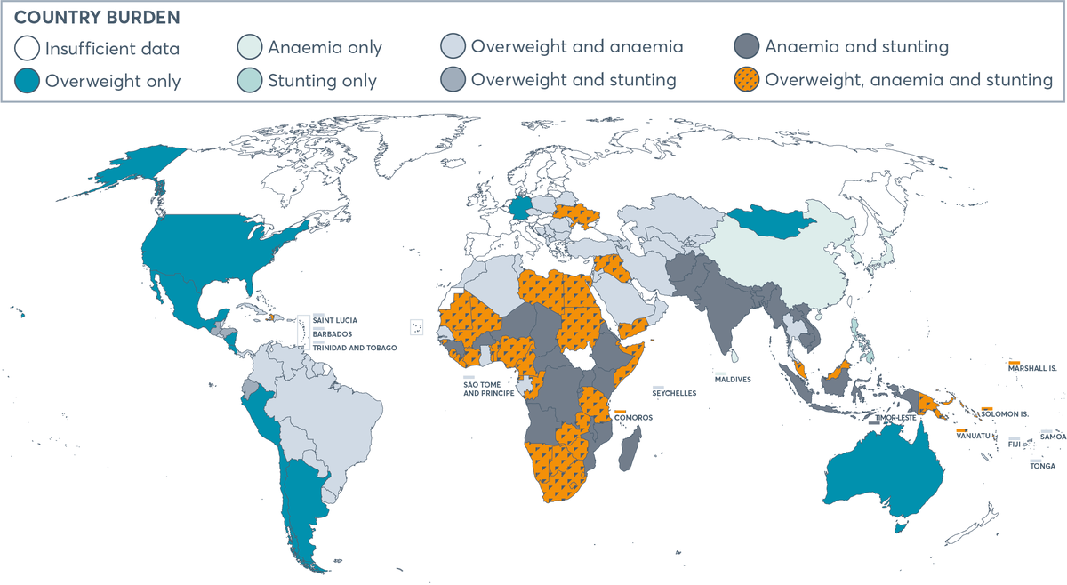
- For each country, which single malnutrition type contributes the most to the overall burden in recent surveys?
  - Visualization: Bar chart comparing revenue by product
  - Screenshot of visualisation
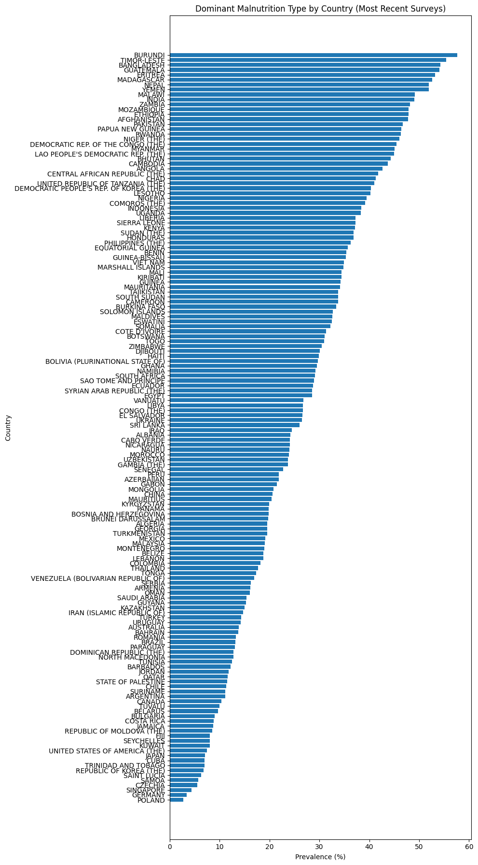

- Which countries face the highest stunting burdens, and how many children are affected based on population size?
  - Visualization: Map visualization showing customer satisfaction by region.
  - Screenshot of visualisation
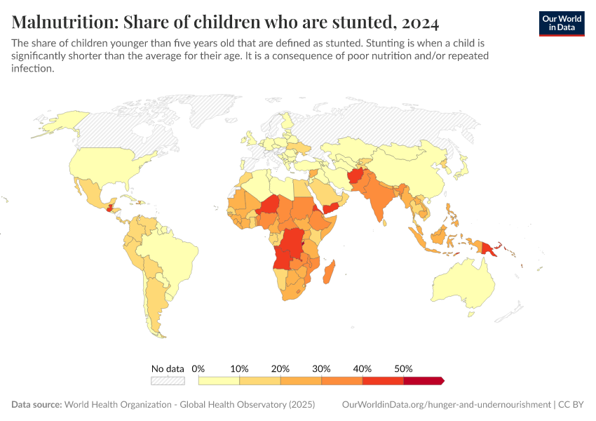
4. How have malnutrition indicators evolved in Afghanistan over survey years?
  - Visualization: Map visualization showing customer satisfaction by region.
  - Screenshot of visualisation

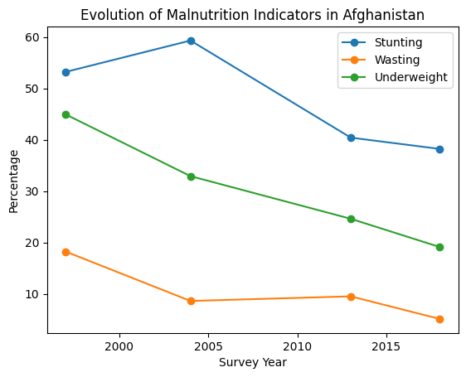

5. Which countries are most affected by different forms of malnutrition?
- Visualization:Grouped bar chart
- Screen shot of the visualization

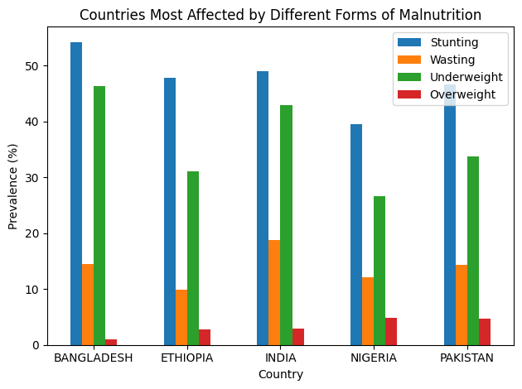

6.Which regions show improvement or deterioration over survey years?

- Visualization: Multi-line chart (one line per region)
- Screenshot of the visualization:

